**THE CATHOLIC UNIVERSITY OF EASTERN AFRICA**

**FACULTY OF SCIENCE**

**DEPARTMENT OF COMPUTER AND INFORMATION SCIENCE**

**E-BAKERY MANAGEMENT SYSTEM: A CASE OF SPARKLING CAKES SHOP**

**JANE WAMBUI KARUGA REG NO:1040477**

**A Research Project Submitted in Partial Fulfillment of the Requirements for the Award of the Bachelor of Science Degree in Computer Science, Catholic University of Eastern Africa**

**NAIROBI, KENYA**

**MARCH, 2023**

**DECLARATION**

I, the undersigned, declare that this proposal is my original work and that it has not been presented in any other university or institution for academic credit.

Signature: …………………………. Date: …………………........

**Name: Jane Wambui Karuga**

**Registration Number:1040477**

Supervisor: This research proposal has been submitted for examination with my approval as University supervisor.

Signature: …………………………. Date: …………………........

**Mr. Ishmael Nicodemus**

**Lecturer**

**Faculty of Science**

**Catholic University of Eastern Africa**

ENDORSED BY HEAD OF DEPARTMENT OF COMPUTER SCIENCE.

Signature: …………………………. Date: …………………........

**Mr. Michael Kinyua**

**Head of Department Computer and Library and Information Science**

**Catholic University of Eastern Africa**

**ACKNOWLEDGMENT**

I thank the Almighty God who gave me the opportunity and strength to pursue my studies to this end. My utmost gratitude goes to my supervisor, Mr. Ishmael Nicodemus who has walked with me throughout my research project by giving me guidance which has been crucial for the successful completion of the project. I am also indebted to my classmates for encouraging me and assisting me with ideas.

**DEDICATION**

This project is dedicated to my grandparents, mother and siblings for their unlimited prayers, financial support and encouragement throughout my academic journey.

**ABSTRACT**

*The bakery industry continues to be one of the fast rising industries in the food sector. However, the use of traditional paperwork to manage the systems causes these bakeries to have a reduced performance rate in terms of their sales since there is a slowdown in other related activities in the stores such as inventory management and in addition, the response time becomes lower especially when the store receives high traffic from the customers. For this reason, the research proposal aims to come up with an e-bakery management system that aims to provide an efficient way for customers to order bakery products online and for inventory management for the managers of the bakery store. For our case, we will focus on Sparkling Cakes shop for case study which is currently utilizing traditional paperwork for management of their store as opposed to a bakery management system. The research has some specific objectives guiding it such as to perform online ordering by the customers in terms of selecting their products and specifying customization, to keep track of inventory levels and facilitate order fulfilment. The system will follow several steps in the research design such as identifying requirements, collection of data through issuance of surveys, observations and document analysis, perform system designing, implementation and testing. The system is web based and shall be implemented using front end technologies that include HTML, CSS and JavaScript. The backend shall be implemented using C# and data will be stored in a MySQL server. In addition, frameworks such as react, bootstrap and .NET will be used to assist the front and backend technologies. The system will be of help to bakery owners, staff and their customers for carrying out a smooth business.*

**TABLE OF CONTENTS**

**DECLARATION i**

**ACKNOWLEDGEMENT ii**

**DEDICATION iii**

**ABSTRACT iv**

**LIST OF FIGURES v**

**DEFINITION OF KEY TERMS ix**

**CHAPTER 1: INTRODUCTION 1**

* 1. INTRODUCTION 1
  2. MOTIVATION AND BACKGROUND 1
  3. BACKGROUND OF RESEARCH 2
  4. PROBLEM STATEMENT 3
  5. AIM OF THE RESEARCH 3
  6. OBJECTIVES OF THE RESEARCH 4
  7. JUSTIFICATION OF RESEARCH 4
  8. SCOPE OF THE RESEARCH 4
  9. RESEARCH ORGANIZATION 5

**CHAPTER 2: RESEARCH METHODOLOGY 7**

2.1 CHAPTER INTRODUCTION 7

2.2 METHODOLOGY FOR LITERATURE REVIEW 7

2.3 METHODOLOGY FOR REQUIREMENT SPECIFICATION 8

2.4 METHODOLOGY FOR SYSTEM ANALYSIS 9

2.5 METHODOLOGY FOR SYSTEM DESIGN 9

2.6 METHODOLOGY FOR SYSTEM IMPLEMENTATION 12

2.7 METHODOLOGY FOR SYSTEM TESTING 13

2.8 METHODOLOGY FOR SYSTEM DEPLOYMENT 14

2.9 CHAPTER SUMMARY 15

**CHAPTER 3: REVIEW OF RELATED WORK 16**

3.1 CHAPTER INTRODUCTION .16

3.2 REVIEW OF RELATED WORK 16

3.3 HISTORY OF THE RESEARCH TOPIC 17

3.4 REVIEW OF RELATED PROTOTYPES 18

3.5 EMERGING TRENDS AND PATTERNS IN THE RESEARCH AREA 19

3.6 RESEARCH GAP TO BE FILLED BY THE RESEARCH 20

3.7 CHAPTER SUMMARY 20

**REFERENCES 21**

**APPENDICES 22**

**APPENDIX A: SAMPLE QUESTIONNAIRE 23**

**LIST OF FIGURES**

Figure 2.5.1: Data Flow diagram of the proposed system 9

Figure 2.5.2: Flow chart diagram of the proposed system. 10

Figure 2:5:3: Sequence Diagram of the proposed system 11

Figure 2.5.3: Use-Case diagram of the proposed system 12

**DEFINITIONS OF KEY TERMS**

HTML Hyper Text Markup Language

**CSS** Cascading Style Sheets

DFD Data Flow Diagrams

URL Uniform Resource Locators

SQL Structured Query Language

**CHAPTER ONE**

**INTRODUCTION**

**1.1: Introduction to chapter one**

This chapter provides an introduction to the e-bakery industry and justifies the need for an e bakery management system. It lays out detailed information on the background and motivation of the research, problem statement, defines the aims and objectives of the research, scope and in addition administers the justification of the research.

**1.2: Background and Motivation**

Over the years, the bakery industry has proven to be one of the rising sectors when it comes to the food industry. According to a report by ResearchAndMarkets.com, the global bakery market is expected to reach $703.1 billion by 2027, growing at a CAGR of 3.8% from 2020 to 2027 (ResearchAndMarkets.com, 2020) This has been influenced majorly by the rising demand for healthy baked products and with low sugar content. For this reason, bakers have become more innovative when it comes to bakery products such as pastries and cakes. This has increased the production of customized baked goods according to the customer’s desires thus leading to better convenience to the customer. However, our local stores still face some challenges when it comes to this industry such as competition from larger bakery chains. Local bakeries face tough competition from larger bakery chains that have more resources and a wider reach. According to a study by IBIS World, the top four players in the bakery industry account for over 45% of industry revenue (IBIS World, 2021). This competition can make it difficult for local bakeries to attract and retain customers.

In addition to this, consumer preferences are constantly evolving, and local bakeries must keep up with the latest trends to remain relevant. For example, there has been a growing demand for gluten-free and vegan bakery products in recent years (Mintel, 2021). Local bakeries that fail to adapt to these changing preferences risk losing customers to competitors. Also, the cost of ingredients used in bakery products, such as flour and sugar, has been steadily increasing over the years. This can make it difficult for local bakeries to maintain profit margins while keeping prices affordable for customers. Technology on the other hand has continuously had a high trajectory growth in terms of how it has been embraced in our day to day lives and its continuous use across the globe by many different users. One of the most significant results of the technology growth is electronic commerce over the Internet, a new way of conducting business, otherwise known as e-commerce. It has made shopping of goods so much easier just with the tap of a button on your device hence no need to hustle with long queues at the physical stores.

The shift towards e-commerce has created a need for an efficient and effective e-bakery management system. Such a system would enable bakeries to manage their inventory, order processing, and delivery operations in real-time, allowing them to optimize their production and minimize waste. By automating various processes, such as order processing, inventory management, and production scheduling, bakery owners can save time, reduce errors, and improve productivity (Alalwan et al., 2017). Furthermore, e-bakery management systems can help reduce costs by optimizing inventory levels, minimizing waste, and improving supply chain management (Islam et al., 2017). Another benefit is improved customer service. With an e-bakery management system, customers can place orders online, track their orders, and receive notifications about their orders' status (Gao & Li, 2019). This convenience can enhance customer satisfaction and loyalty, leading to increased sales and revenue for the bakery.

**1.3: Background of Research**

With the current advances in technology, bakeries need to embrace adaptability to the new area of digitization in order to keep up with the competitive game in their industries. This does not only limit to large businesses but also small businesses that have a goal for growth in their business. This includes introduction to electronic Bakery Management Systems to the local retail bakeries so that customers can have an easy access to book online for their cakes and pastries and also the store can have an efficient way of managing their customers from their end and be well prepared even for their busy days. For our research, we will sample a local bakery in Nairobi; Sparkling cakes which majors in sale of cakes.

**1.4: Problem Statement**

For every industry in business, it has to experience some drawbacks while it is being run and for Sparkling Cakes company, it is not limited from experiencing some of these challenges. For inventory management, the retailer has a challenge in terms of tracking the products in the store from when received by the supplier to when it is almost running low in terms of usage and the amount of wastages they have incurred when selling to their customers since a manual stock taking may have its inaccuracy.

In addition to this, they experience some challenges in terms of collecting and handling multiple large sale orders effectively. This is brought up especially when the customers all have a same timeframe for delivery of the cakes. This easily causes confusion for the retailer if not handled in a systematic order and furthermore, a customer’s order can easily mix up with another or others to be easily forgotten thus causing inconveniences and dissatisfaction to their customers. The store also experiences some challenges in terms of its popularity. This is in that for the customer to know of its existence, one has to visit the area and spot it, learn about it and then place an order from there or call the number displayed on the stores door. And if they place an order via the phone, there is the uncertainty by the customer that the order was taken correctly since there is no visual confirmation of the customer’s order that is issued to them.

**1.5: Aim of the Research**

This research is aimed at developing an automated Bakery system which will be able to have the customers sign up into the system and check out all the available products the store offers. Thereafter, the client can make a booking for the product of choice and a receipt can be afterwards generated to them to confirm that what they have ordered is what has been keyed into the system and be issue with an exact date when they can come for their cake. Once this has been taken in, the customer can be prompted to pay via a mobile operator such as Safaricom so that the order can start being processed.

On the administrator’s end, the store retailer will be able to upload the products they have from their end for the clients to view and be able to remove products that are out of stock for the day or have been removed indefinitely. The retailer can also view the product(s) requested by the customer from their end and start processing it within the timeframe allocated and also generate a report for the orders received for a particular day or week. The retailor can also key in the deliveries received from the supplier and track its usage.

**1.6: Objectives of Research**

**1.6.1: Main Objective of Research**

The main objective of this research is developing an e-Bakery management system.

**1.6.2: Specific Objectives of Research**

The research has some specific objectives that it aims in achieving at the end of the research. This includes the following:

1. Identifying the current challenges faced by small bakery owners in managing their business operations.
2. Identifying the key features and functionalities required for the bakery management system
3. To design and develop a prototype e-Bakery Management System based on the identified features and functionalities.

**1:7: Justification of research**

The bakery industry is a highly competitive and complex sector that presents many challenges to local stores. To overcome these challenges and remain competitive, local bakeries must adopt innovative technologies that help them streamline operations, reduce costs, and improve customer satisfaction. An electronic bakery management system is one such technology that can provide significant benefits to local bakeries. An e bakery management system can provide numerous benefits to bakeries such as improved efficiency in bakery operations. According to Kumar and Singh (2016), electronic systems enable bakery owners to automate many of their processes, such as inventory management, order processing, and payment collection. This automation reduces the time and effort required to perform these tasks manually, allowing bakery staff to focus on other critical areas of the business, such as customer service and product quality.

In addition to improved efficiency, e-bakery management systems also offer better inventory management. A study by Zouari, Dhouib, and Kachouri (2018) found that electronic systems can help bakery owners track their inventory in real-time, reducing the risk of overstocking or understocking. This real-time tracking also enables bakery owners to make informed decisions about pricing, promotions, and product development.

Another benefit of e-bakery management systems is enhanced customer satisfaction. With electronic systems, customers can place their orders online, reducing wait times and improving convenience. Kumar and Singh (2016) suggest that online ordering systems can also reduce the risk of errors, such as incorrect orders or miscommunication between customers and bakery staff. Overall, e-bakery management systems can improve customer loyalty and retention by providing a seamless and hassle-free ordering experience.

**1:8: Scope of the project**

The research will be purposed in targeting local small bakeries who have not yet explore the idea of introduction of technology to their businesses and wish to take their businesses to the next level. However, this research will only cover approximately sixty people and examine their use of the online bakery system. This research will be conducted in a period of three months and will majorly focus on identifying problems that clients face when obtaining services in bakeries and also problems that the local retailors face in managing their bakery stores.

**1:9: Research Organization**

This research has been broken own to detail into three chapters which is as follows:

Chapter One covers the Introductory part. It entails: Introduction of the research, background and motivation of the research, definition of the problem statement, the aim and objectives of the research, the justification and the scope of the project.

Chapter Two covers the Research Methodology to be used in the project. It entails: The Literature Review, Requirements Specifications, The System Analysis, Design, Implementation, Testing and Deployment of the project.

Chapter Three covers the previous works that are related to this project.

**CHAPTER TWO**

**RESEARCH METHODOLOGY**

**2.1: Introduction to Chapter Two**

This chapter provides a comprehensive methodology review on the literature of electronic bakery management systems. In addition, it will also cover the analysis, design, implementation, testing and deployment of the system.

**2.2: Methodology of Literature Review**

For this research project, several methodologies were used to evaluate the earlier work done and assess the information that is accessible in the literature relevant to e-bakery systems which includes the features, benefits, challenges and adoption rates that are associated with the system. Some of them include review of relevant journals, newspapers, publications and blogs, which have an aim of providing an overview of the current trends and best practices in the relevant scope. Potential search terms related to e-bakery management systems can be used in conducting a search for relevant articles before screening and analyzing the literature. This may include: “Bakery Software”, “Digital bakery management” and “Online Bakery management”. This in turn can be used as guidelines in producing a seamless electronic bakery management system.

**2.3: Methodology for Requirement Specification, data collection and analysis technique**

**2.3.1: Requirements Specifications**

The envisioned system will entail requirements that are to be imposed on its design and verification. These requirements include identification of the stakeholders who are the owner(s) of Sparkling Cakes shop, employees, customers and suppliers for the ingredients.

In addition, the functional requirements for this system are highlighted as follows:

The system should have an ability to allow customers to place an online order (choose the size and add custom notes of the color designs they would like their cake to have decorated with), select delivery options and make a down payment securely.

The system should allow the bakery owner(s) to update the menu with ease, which includes adding, removing and modifying the products in the store depending on their availability and their prices.

The system, furthermore should be able to provide instantaneous information about the inventory level of ingredients, supplies and finished products and alert the bakery owner(s) when supplies need to be restocked.

The system should grant the bakery employees access to efficiently process and fulfill orders in terms of managing order queues, tracking order status and coordination of the delivery to the customer/pickup of the order.

The envisioned system also has non-functional requirements which are laid out as shown:

The system’s response time to order placement and payment procedure should be quick and can handle a large number of orders and transactions from customers without causing a slow down or in worst scenario crashing of the system.

The system should be user friendly and easy to use for all the stakeholders to navigate through and access the system.

The system must be available at all times with minimal maintenance delays.

The system ought to work with many different web browsers, operating systems and gadgets.

The system should be scalable in that it can handle increased traffic and additional features as the business grows.

**2:3:2: Data Collection Methods**

Several methods were used in the data collection process which include surveys, direct observation and document analysis.

**2:3:3: Issuance of Surveys**

The researcher can create a one-minute online survey for the customers at the store to fill after purchasing a product on their feedback in regards to the speed of service, customer service satisfaction and overall satisfaction of the purchase process. The last section of the survey could have the customer express what they would like to be improved to make the store run better.

**2:3:4: Direct Observations**

For some stakeholders such as the employees and the bakery owner(s), the researcher can look at how they are utilizing the bakery management system, for instance, how they use the inventory management system for a period of time. From this observation, the researcher can make an analysis and thereafter provide insights on how to improve the system’s usability.

**2:3:5: Document Analysis**

The researcher can take a look at existing documentations of the store such as the sales, order history and customer feedback reports of the store within a certain timeframe. The use of these existing documents to the researcher is so that they may get a more detailed insight about the store in terms of the customer’s preferences, ordering trends and other important data points that may assist them in their analysis.

**2:4: Methodology for System Analysis**

System analysis is a structured process that involves examining and evaluating the components of a system and their interrelationships to identify opportunities for improvement or optimization (Bassil, 2015; Siau and Rossi, 2011). The purpose of this analysis is so that the researcher has a complete understanding of the requirements and can guarantee that the proposed system will be developed in accordance with those requirements. The components of the system need to be first identified and generate a conceptual model thereafter from the components for the purpose of determining how effectively each component works together to fulfill its function.

**2.5: Methodology for System Design**

According to Hoffer, George and Valacich (2014), system design is the process of specifying a detailed computer based solution for a business problem or opportunity. (Gheorge et al,.2017) indicates that system design ensures that the system is designed to operate efficiently, making it more reliable and stable. To achieve the research objectives and research problems, this study adopted the logical design by using the Data Flow Diagrams, Flowcharts and Sequence diagrams. Use case diagrams will be used to explain how the system's various actors will interact with it in the physical design.

**2:5:1: Data flow Diagram**

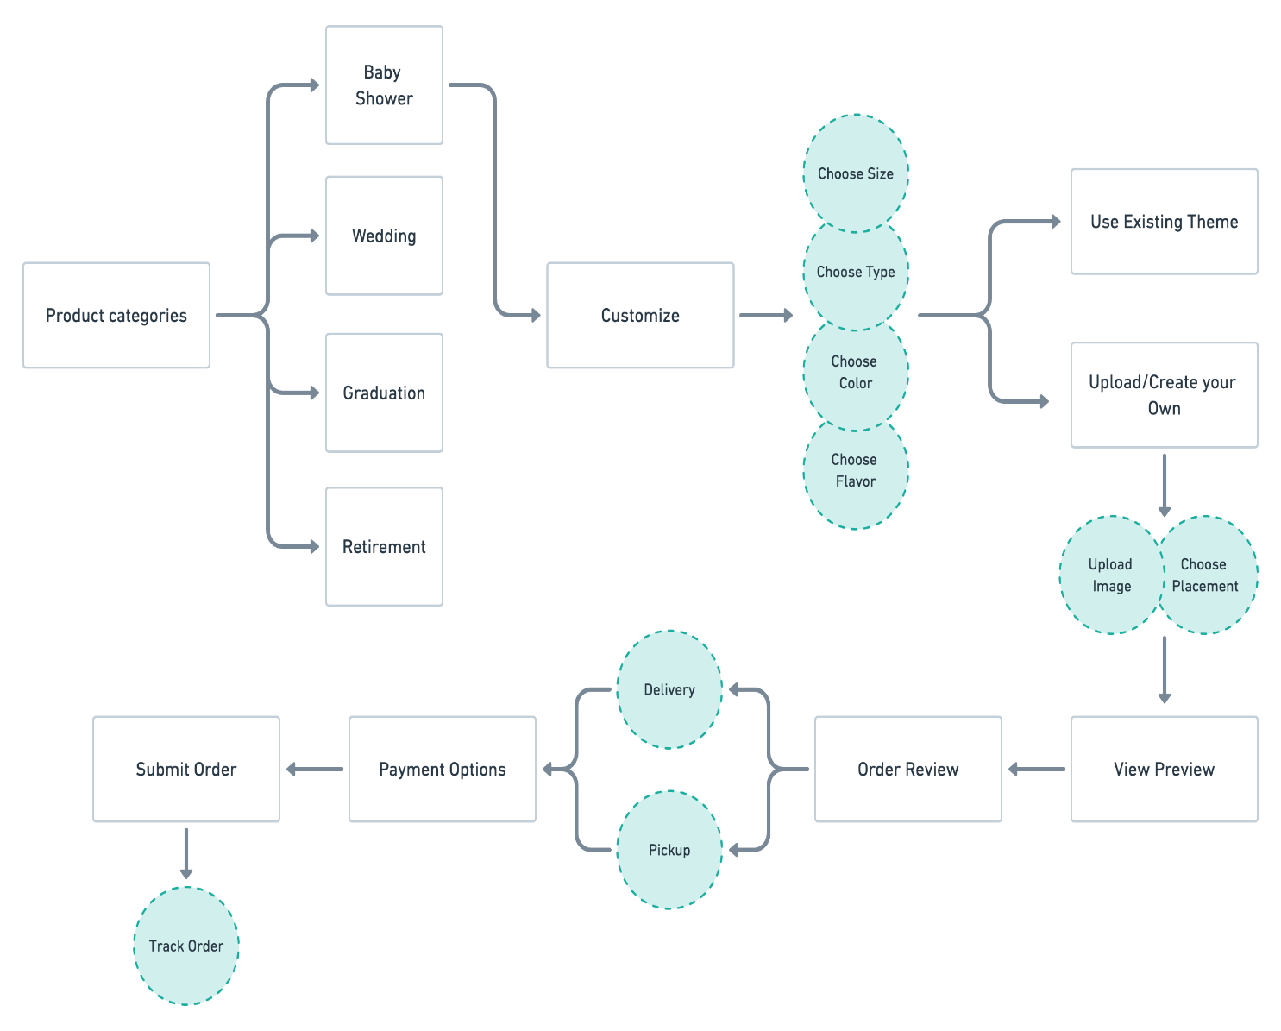

**Figure 2.5.1: Data Flow Diagram of the Ordering page in an e-Bakery Management System (andreolidesign.com,2023)**

**2:5:2: Flowchart**

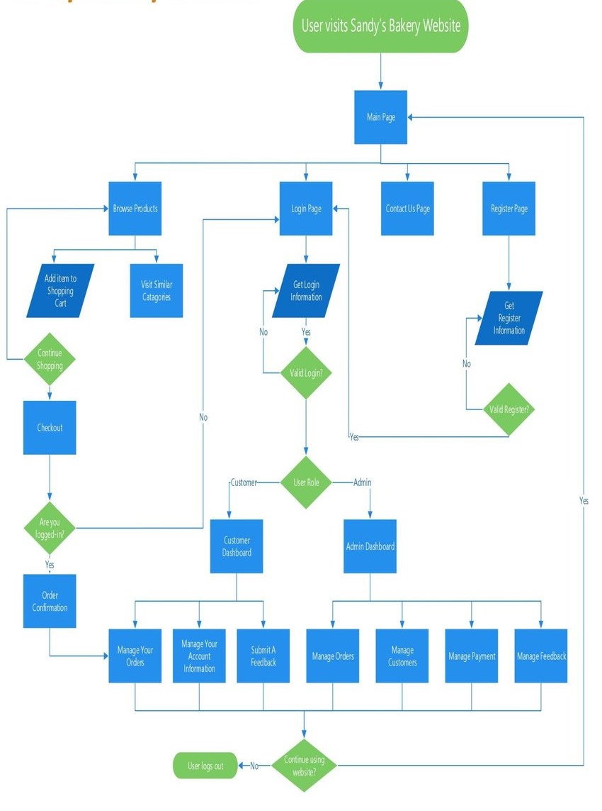

**Figure 2:5:2: Flowchart Diagram of the envisioned e-Bakery Management System(ResearchGate,2023)**

**2:5:3: Sequence diagram**

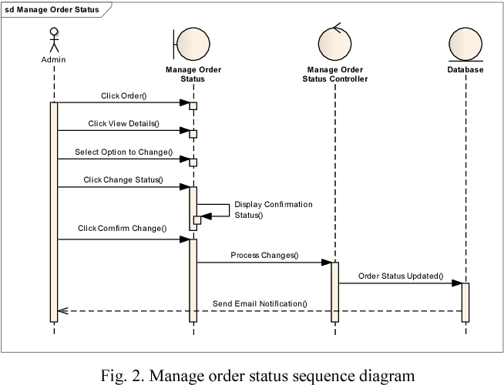

**Figure 2:5:3: Sequence Diagram of the Order page of an e Bakery Management System(Author,2023)**

**2:5:4: Use case Diagrams**

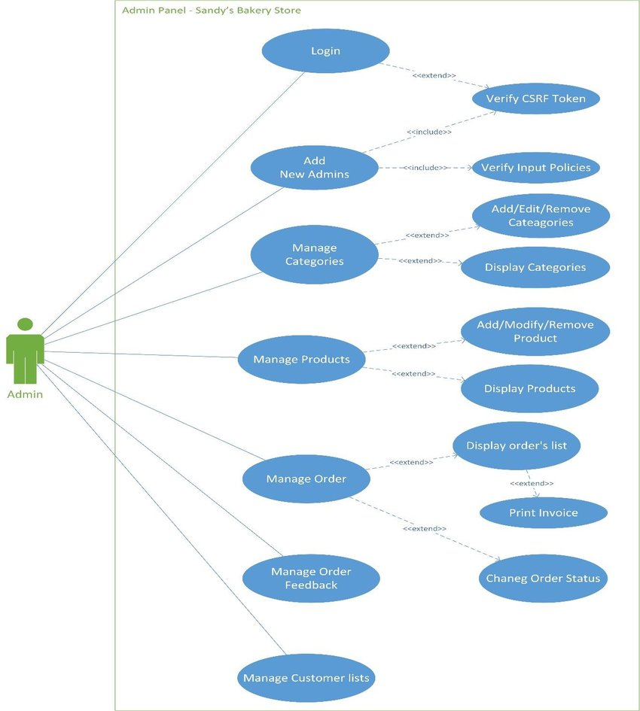

**Figure 2:3:4: Use case Diagram of the backend for the proposed e-Bakery Management System (ResearchGate,2023)**

**2:6: Methodology for System Implementation**

For the proposed system, it will be operational as a web based application whereby it can be accessed by any operational browser. In this section, in-depth details of the front end, back end and database technologies will be discussed for quality assurance purposes.

**2:6:1: Back End Technologies**

According to IBM, the backend is where the magic happens in a web application. It is the server-side of the application, where data is stored, processed, and served to the client-side. ("What is Backend? Definition and Examples," IBM, 2022). Our proposed system will be utilizing C# and .NET framework as our backend technology. Its flexible ability to update and maintain the system over time, integrate with other applications and systems, reliability and security features make it the suitable backend technology to utilize during the project. It will be responsible for storage and management of data used by the system as well as facilitate the processing of requests from the front end and communicating with other systems that are integrated to the bakery system such as payment gateways. In addition, the business logic of the system will be implemented here in instances such as determining the prices of products, calculating sales tax, and managing promotions and discounts.

**2:6:2: Front End Technologies**

The envisioned system will make use of front end technologies such as HTML, CSS and JavaScript. The users who are the customers in our case will be presented upon firstly the eye-catching Home page made by mostly HTML and CSS for the designing. It will contain an overview about the company, Login/Register, Contact Us and the Order pages respectively. Before a user makes an order, they will be prompted to create a new account if they are new or login if they are regular customers through a pop up window. All new users’ details will be captured by filling a form created by HTML which will contain personal details such as the customer’s names, age, phone number and area of residence. Validation of the user’s details will then be implemented by the use of JavaScript. The order section will then allow the user to customize what they would like to have to their preference through a drop down menu. In addition, some libraries and frameworks will be utilized such as React and bootstrap for JavaScript and CSS respectively. React will be of need when creating the product catalogue with filtering and sorting options whereas bootstrap will assist in creating responsive web pages that adapt to different screens and sizes. Uniform Resource Locators (URLs) will also be used in our application for navigation purposes through the different web pages and for social media sharing purposes.

**2:6:3: Database Technologies**

Our system will utilize a relational database which stores data in tables with each table representing a different type of data such as inventories, sales, customers or employees. The management system to be used will be MySQL and the language to be used to query in the database will be Structured Query Language(SQL).

**2:7: Methodology for System Testing**

System testing is a major stage when developing an e bakery management system as it certifies that the application under test(AUT) meets the client’s expectation. Various testing methodologies shall be used to validate the application under test which majorly include functional and non-functional testing. However, a test strategy is in need beforehand so as to cater for the estimations and resources and create a schedule for when each testing will take place. For this, a test plan is created to act as a blueprint of how the testing will take place.

**2:7:1: Testing Plan**

The test plan is a dynamic document that acts as a blueprint of how the testing activity is going to take place in the project. It will have specific objectives of ensuring the bakery management system meets the functional and non-functional requirements, validate the system’s performance, reliability and security, verify the usability and accessibility of the system and lastly identify and document any defects found during the testing process. The various requirements to perform the testing for instance the hardware and software requirements, test data and resources, tools and technologies and the test environment setup need to be noted down in the test plan so that the testing activity may be successful.

**2:7:2: Testing Techniques**

Various techniques will be used to test the application under test against the functional or non-functional requirements gathered from business. For functional requirements, Unit testing, which is the first level of testing will be performed by the developer to ensure everything is running smoothly. Integration testing can then be used to determine whether the system's components are interacting in such a way that there is no contradiction between the system's functionality and the requirements listed in the requirements document. The researcher can also conduct system testing to confirm that the complete system is operating as intended and satisfies the set criteria. The system's suitability for the user's requirements must also be confirmed through acceptance system testing.

For non-functional requirements, performance testing can be undertaken to test how much time it takes to process an order after ordering under different scenarios. Usability test can also be performed to check if the system is user friendly for all stakeholders, including those with no technical background. Each of these techniques are performed so as to find a specific kind of defect.

**2.8 Methodology for System Deployment**

System deployment involves the processes used to plan for and manage the transition of new or evolved systems and capabilities into operational use and the transition of support responsibilities to the eventual maintenance or support organization. The stakeholders of the company must first be communicated to confirm that the system is ready for deployment. Thereafter, the system has to be checked once more to ensure that it is fully tested and all defects are resolved. An automated software package can be created via templates before releasing the system to the end users. Configuration of the system can then be done while performing training to the end users to ensure they understand how to use the system before lastly establishing a maintenance plan to ensure the system is regularly updated and monitored.

**2:9: Chapter Summary**

This chapter has descriptively been able to bring out the requirements specifications of the system, the various data collection methods to be used for analysis and the methodologies utilized right from the analysis all the way through till the deployment stage.

**CHAPTER THREE**

**REVIEW OF RELATED WORK**

**3:1: Introduction**

This chapter entails the studying and analyzing of previous works related to electronic bakery management system in regards to its history. In addition, related prototypes and emerging trends and patterns in the bakery management system industry are reviewed.

**3:2: Review of related work**

As more and more bakeries have turned to technology to help them manage their operations, e-bakery management systems have gained popularity in recent years. In the context of e-bakery management systems, some of the most important research and literature will be examined in this review of related work.

In one research, Kulkarni and Deshpande (2017) looked at how the bakery industry uses e-commerce. The majority of the 100 Indian bakery owners surveyed by the authors expressed an interest in expanding their customer base and increasing sales through e-commerce. However, they also discovered that due to concerns on security and the technology's complexity, many bakery owners were reluctant to embrace e-commerce.

In another research, Hu, Huang and Fang (2018) investigated small and medium bakeries’ use of e bakery management systems. By streamlining operations and reducing waste, the authors discovered that these systems can boost these businesses' profitability and efficiency.

In addition to these studies, there have also been a number of case studies exploring the use of e-bakery management systems in specific contexts. For example, a case study by Goyal, Gupta, and Aggarwal (2018) looked at the implementation of a web-based e-bakery management system in a bakery in India. The authors found that the system improved inventory management and order processing, leading to increased customer satisfaction and profitability.

Overall, the research and literature suggest that bakery businesses can benefit from e-bakery management systems in a variety of ways, including increased profitability, coordination, and efficiency. Nonetheless, the progress of these systems relies upon various factors, including the particular requirements of the business, the nature of the innovation, and the expertise of the staff who use it.

**3:3: History of the Research Topic**

The history of e-bakery management systems can be traced back to the development of e-commerce and online ordering systems in the early 2000s. As more and more businesses began to establish an online presence, bakeries also started to explore the potential of e-commerce for their operations.

According to a study by Hu, Huang, and Fang (2018), the first e-bakery management systems were developed in the mid-2000s, with the primary focus on online ordering and delivery tracking. These systems allowed customers to place orders online and track the progress of their orders, from the time of order placement to delivery. As technology continued to evolve, e-bakery management systems began to incorporate additional features and functionalities. For example, some systems included inventory management tools, allowing bakeries to track their inventory levels and manage their supplies more efficiently.

In the following years, e-bakery management systems continued to evolve and become more sophisticated. By the mid-2000s, some systems were capable of managing a wide range of bakery operations, including inventory management, order processing, and customer relationship management (CRM). Today, there are a wide variety of e-bakery management systems available on the market, ranging from simple online ordering platforms to comprehensive enterprise resource planning (ERP) systems. These systems offer a range of features and functionality, allowing bakery businesses to choose the system that best meets their needs.

Overall, the history of e-bakery management systems reflects the growing importance of technology in the bakery industry. As the industry has become increasingly competitive and customer expectations have risen, bakery businesses have turned to e-bakery management systems to help them stay ahead of the curve.

**3:4: Review of Related Prototypes and Systems**

Numerous research projects have focused on e-bakery administration systems, which have since evolved into a number of prototypes and systems. The important study and literature in the field of e-bakery management systems will be examined in this overview of related prototypes and systems.

A mobile e-bakery management system that can assist bakers in managing their supplies, output, and orders is one of the examples that have been created. Kim, Hong, and Park (2015) created this system and discovered that it increased customer happiness, decreased mistakes, and improved baking operations efficiency.

A web-based e-bakery management system prototype has also been created; it has functions like client relationship management, transaction processing, and inventory management. This program was created by Bhatti and Kamal (2019) and discovered that it made bakeries more productive and profitable by streamlining their operations.

In addition to these prototypes, a number of systems have been developed and put into practice in actual settings. A custom e-bakery management system, for instance, was implemented by the Dutch bakery chain Bakker Bart, enabling the company to manage its inventory, production, and orders more effectively (van der Zee, 2017). A customer loyalty program was also included in the system, which contributed to increased customer retention and loyalty.

A number of professional e-bakery administration systems, such as BakeSmart, CakeBoss, and CakeHR, are offered on the market in addition to these prototypes and systems. These systems offer a number of features, including, among others, online purchasing, recipe administration, inventory management, and sales monitoring.

Overall, the study and writings indicate that e-bakery management systems can offer bakery companies a number of advantages, such as increased output, revenue, and efficiency. The different systems and examples that have been created show the promise for e-bakery management systems to assist bakeries in overcoming the challenges of a more competitive and technologically advanced sector of the economy.

**3:5: Emerging Trends and Patterns in the Area**

In recent years, there has been a growing interest in the use of technology for e-bakery management systems. As the bakery industry becomes increasingly competitive and customer expectations rise, bakery businesses are looking for ways to improve their efficiency and enhance their customer experience. One of the major fast rising trends when it comes to the bakery industry is that of customers increasingly ordering bakery products online as a result of the rise of mobile apps and e-commerce platforms. According to (Ma et al., 2020), e-bakery management systems that provide online ordering and delivery capabilities can assist bakeries in acquiring new customers, increasing sales, and increasing customer loyalty.

Another emerging trend is the integration of artificial intelligence (AI) in e-bakery management systems. AI can be used to optimize bakery operations such as inventory management, production planning, and quality control. For example, AI algorithms can analyze sales data to predict demand and optimize inventory levels, or they can monitor production processes to identify quality issues in real-time (Savchuk et al., 2021). This trend is likely to continue as AI technology becomes more accessible and affordable.

The growing application of data analytics in e-bakery management tools is another pattern that is emerging. Bakery companies now have access to a wealth of data on consumer behavior, production procedures, and supply chain operations thanks to the growth of digital platforms and Internet of Things(IoT) devices. This data can be used for data analytics to gain useful insights, such as finding patterns in consumer tastes, streamlining production, and enhancing supply chain effectiveness. (Gong et al., 2020).

Overall, these emerging trends and patterns are shaping the future of e-bakery management systems, providing bakery businesses with new and innovative ways to improve their operations and provide value to their customers.

**3:6: Research gaps to be filled by the Research**

Despite the significant progress made in the development of e-bakery management systems, there are still several research gaps that need to be addressed. Some potential gaps to be filled may include:

Lack of studies that investigate the impact of e-bakery management systems on small and medium-sized bakeries. Most of the existing studies have focused on larger bakery chains, and there is limited research on how these systems can be adapted to the needs of smaller businesses. This is a critical gap since smaller bakeries may face different challenges and constraints in adopting e-bakery management systems, such as limited resources and technical expertise.

Another research gap is the limited attention given to the impact of e-bakery management systems on the customer experience. Although these systems can help bakeries improve their efficiency and reduce costs, their impact on the customer experience has not been fully explored. For example, how do these systems affect the speed and accuracy of order processing, the quality of products, and the overall satisfaction of customers? Answering these questions can help bakeries better understand the value of e-bakery management systems and improve their customer service.

A third research gap is the limited integration of e-bakery management systems with other technologies such as artificial intelligence (AI) and block chain. Although some studies have explored the potential of these technologies in the bakery industry, their integration with e-bakery management systems is still in its early stages. For example, how can AI be used to optimize production schedules and improve product quality? How can block chain be used to improve the traceability and transparency of the supply chain? Answering these questions can help bakeries unlock new opportunities for innovation and competitiveness.

In summary, there are several research gaps that need to be filled in the e-bakery management system area. Addressing these gaps can help bakeries better understand the potential of these systems, adapt them to their specific needs, and unlock new opportunities for innovation and competitiveness.

**3:6: Chapter Summary**

From this chapter, we have been able to get a clear understanding of related works from getting a perspective from its history, review of related works, review of related prototypes and systems, emerging trends and patterns in the area and lastly the research gaps that need to be filled in that area.

**REFERENCES**

Grand View Research. (2021). Bakery products market size, share & trends analysis report by product (bread, breakfast cereals, cakes & pastries, biscuits), by distribution channel (offline, online), by region, and segment forecasts, 2021-2028. Retrieved from https://www.grandviewresearch.com/industry-analysis/bakery-products-market

Statista. (2021). Global bakery market size 2018-2024. Retrieved from https://www.statista.com/statistics/804974/bakery-market-size-worldwide**/**

Kulkarni, S., & Deshpande, S. (2017). An empirical study of e-commerce adoption in Indian bakery industry. International Journal of Advanced Research in Computer Science, 8(5), 745-752.

Hu, X., Huang, C., & Fang, M. (2018). Research on e-bakery management system of small and medium-sized enterprises. In 2018 2nd International Conference on Management Science and Management Innovation (MSMI 2018) (pp. 128-132). Atlantis Press.

Alam, M. M., Islam, M. R., & Alam, M. J. (2019). Implementation of an E-bakery management system: A case study in Bangladesh. Journal of Engineering and Applied Sciences, 14(10), 3341-3348.

Goyal, S., Gupta, S., & Aggarwal, S. (2018). Implementation of web-based e-bakery management system in a bakery in India: A case study. International Journal of Applied Engineering Research, 13(23), 16824-16830.

Yildirim, K. (2020). A systematic review of e-bakery management systems. Computers in Industry, 120, 103311.

Hoffer, J.A., George, J.F., & Valacich, J.S. (2014). Modern Systems Analysis and Design, 8th Edition. Pearson.

Gheorghe, M., Popescu, D., Trandabat, D., & Gheorghe, L. (2017). Importance of System Design in Software Development Life Cycle. Procedia Engineering, 181, 284-289.

Murray, C., & Langlois, G. (2013). Developing a bakery management system. In 2013 IEEE Global Engineering Education Conference (EDUCON) (pp. 372-378). IEEE.

Bhatti, R. A., & Kamal, M. A. (2019). Web-based e-bakery management system. In 2019 3rd International Conference on Computing and Networking (CANDAR) (pp. 383-388). IEEE.

Al-Hinai, H. A., & Al-Qatab, R. M. (2018). E-commerce adoption in small and medium enterprises (SMEs) in developing countries: A systematic review of literature. Journal of Entrepreneurship, Management and Innovation, 14(2), 65-89. doi: 10.7341/20181426

Kapoor, K. K., Dwivedi, Y. K., & Williams, M. D. (2016). From information management to information governance: New opportunities and challenges. Journal of Information Science, 42(1), 1-17. doi: 10.1177/0165551515594563

**APPENDICES**

**APPENDIX A: SAMPLE QUESTIONNAIRE**

**e-Bakery Management System Questionnaire: To provide an understanding of the use of bakery management systems and evaluate its impact on customers**

**Biodata**

Please fill in the spaces below marked with asterisks (*) before beginning the questionnaire.

*Kindly specify your gender: _____________________

*What age are you currently: _____________________

*How long have you been a customer at Sparkling cakes (Indicate First Time for new customers): _____________

**Instructions**Please answer the following questions in the spaces provided by ticking where it may apply for you. Thank you

1. How frequently do you visit Sparkling Cakes Shop for purchases?

Daily

Weekly

Monthly

Rarely

Never

1. Have you ever experienced any inconvenience while purchasing from Sparkling cakes shop?

Yes

No

1. How likely are you to use an e-bakery management system for purchasing baked goods?

Very likely

Somewhat likely

Neutral

Somewhat unlikely

Very unlikely

1. What features would you expect from an e-bakery management system?
   * + Online ordering
     + Delivery tracking
     + Customized orders
     + Loyalty programs
     + Discounts and coupon
     + Others (please specify)
2. How important is it for you to be able to track your order status and delivery?

* Very important
* Somewhat important
* Neutral
* Not very important
* Not important at all

6. How satisfied are you with the quality of the baked goods you receive from the e-bakery?

* Very satisfied
* Somewhat satisfied
* Neutral
* Somewhat dissatisfied
* Very dissatisfied

1. Is there anything else you would like to share about your experience with e-bakeries or suggestions for improvement? Please feel free to write down your answer. _____________________________________________________________________________________________________________________________________________________________________________________________________________________